
SE-401 Human Computer Interaction
Sir Dr. Hamid Ullah
15 March 2026
Ali Khan – 23MDSWE248
HCI Assignment 2
University of Engineering and Technology Mardan
Task#1: UI Mockup Design
Solution:
Tool: Canva
Reference & Help: https://www.youtube.com/watch?v=JnWYwvT7zUI

Figure 1 Hero Section
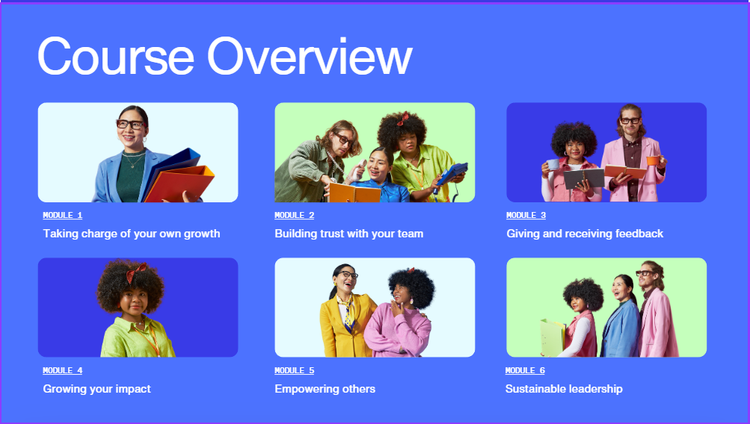
Figure 2 Overview Section
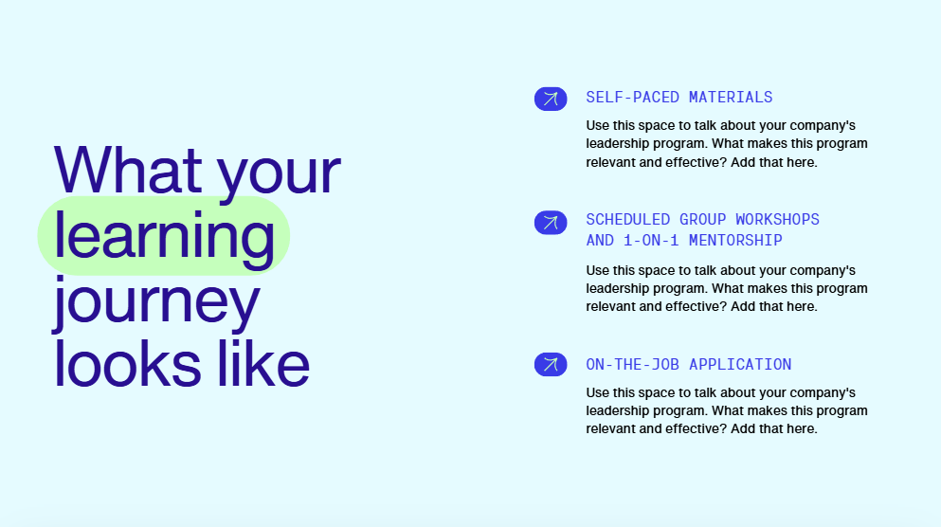
Figure 3
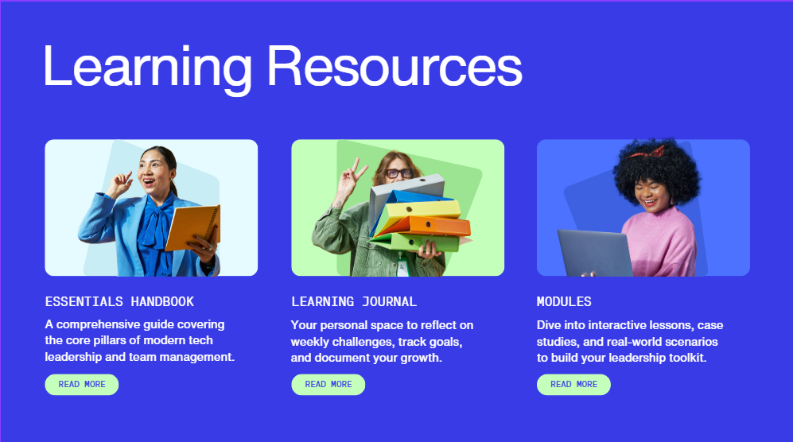
Figure 4
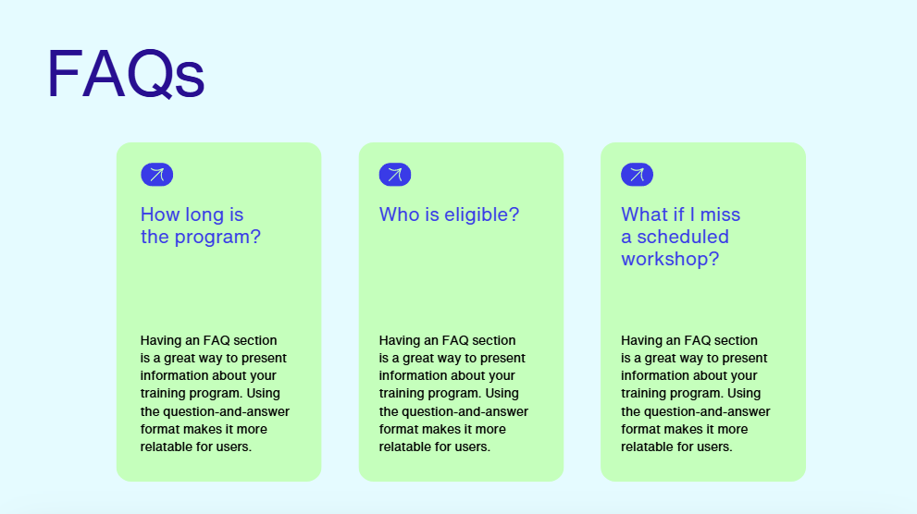
Figure 5

Figure 6

Task #2: Usability Principles
Solution:
- Consistency:
• Where: Across all pages, specifically the color palette (Electric Blue, Mint Green, and Purple) and button styles (rounded "Mint Green" buttons like "Start Learning" and "Read More").
• Why: Consistency reduces the user's learning curve. By making all clickable actions look identical, the user doesn't have to guess what is a button and what is just a decoration.
- Visibility:
• Where: The Hero Section (Figure 1) and FAQ Section (Figure 5).
• Why: Important information is placed prominently. The "Start Learning" button has high contrast against the blue background, making the primary call-to-action (CTA) immediately visible. In the FAQ, the questions are large and bold, ensuring users can find answers without digging through small text.
- Feedback
• Where: The Navigation/Arrow Icons on the "Learning Journey" (Figure 3) and FAQ cards (Figure 5).
• Why: In a real web app, these arrows indicate that the element is "expandable" or "clickable." They provide a visual cue (pre-emptive feedback) that more information is available, preventing the user from feeling stuck.

Task #3: Human Information Processing
Solution:

1. Supports User Attention
- Visual Hierarchy: Your design uses size and color to direct the eye. In the Hero section, the large "Welcome" text is the first thing seen, followed by the secondary description, and finally the bright green button.
- Directional Cues: In the Hero image, the person is looking toward the center of the page/content. Naturally, humans follow the gaze of others, which pulls the user's attention into the text.

2. Reduces Memory Load
- Recognition over Recall: Instead of making users remember what is in each module, you used Image Cards (Figure 2). The combination of a module number, a title, and a descriptive photo helps users recognize the topic instantly without having to memorize the syllabus.
- Chunking: The "Learning Journey" and "Learning Resources" sections break down complex information into three distinct "chunks" (cards). Humans process 3 to 4 pieces of information much better than a long list.

3. Improves Understanding
- Consistency of Symbols: You used the same arrow icon across multiple pages. This creates a "mental model" once the user understands that an arrow means "go deeper," they understand how to navigate the entire site.
- Plain Language: Using clear headings like "What your learning journey looks like" and "FAQs" avoids technical jargon, making the purpose of each section immediately clear to any student.

Task #4: HTML/CSS Implementation
Solution:
HTLM Code:
CSS Code:
Task#5:
Solution:
Successfully Uploaded to GitHub repository

